Exporting AcqKnowledge Files into Excel

1. To resample the graph, go to Transform, then “Resample Graph.”

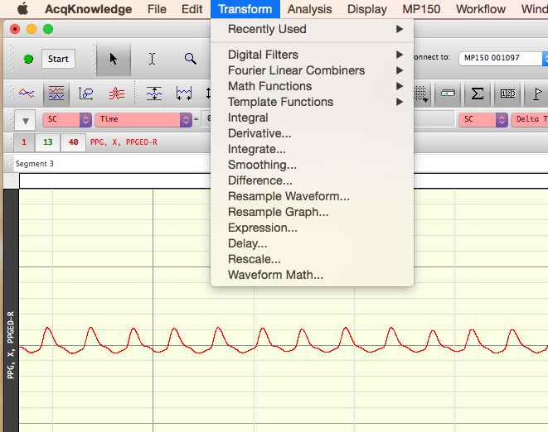

1. A dialog box should pop up prompting you to enter a new graph sampling rate. Enter 50 samples/second. Make sure the interpolation method is set to Linear. Then, click OK.

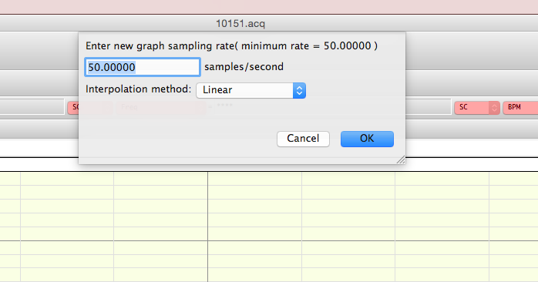

After clicking OK, you should notice the graph compress slightly.

1. Finally, to import the resampled graph into Excel, go to File and then “Save As.” Save the file as an Excel Spreadsheet (\*.xls) in the desired folder.

